Lab 04 : Basic Inheritance
Student Name: Jichichi Clive T
Registration Number: H250254B
Programme: Software Engineering
Date: 9/10/2026
Exercise 1
Aim: To demonstrate inheritance by creating a Student class that extends Person.
Source Code
Person.java

package lab04inheritance;

// Parent class containing common person details
public class Person {

protected String name;
protected int age;

// Constructor initializes the person's details
public Person(String name, int age) {
this.name = name;
this.age = age;
}

// Displays common person information
public void display() {
System.out.println("Name: " + name);
System.out.println("Age: " + age);
}
}
Student.java

package lab04inheritance;

// Student inherits the fields and methods from Person
public class Student extends Person {

private String course;

// Constructor passes name and age to the parent constructor
public Student(String name, int age, String course) {
super(name, age);
this.course = course;
}

// Displays the inherited details and the student's course
@Override
public void display() {
super.display();
System.out.println("Course: " + course);
}
}
Main.java
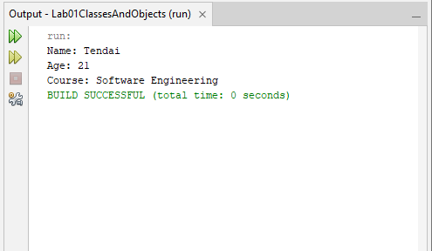
Explanation: The Person class stores the common attributes name and age and provides a display() method. The Student class inherits these features and adds a course attribute. The super() statement initializes the parent class, while super.display() reuses the parent's display functionality.
Conclusion: The program demonstrates code reuse through inheritance and shows how a subclass can extend the functionality of a parent class.

Exercise 2: Hierarchical Inheritance
Aim: To demonstrate how multiple subclasses can inherit from the same parent class.
Source Code
Teacher.java

package lab04inheritance;

// Teacher inherits common details and behaviour from Person
public class Teacher extends Person {

private String subject;

// Initializes inherited fields and the teacher's subject
public Teacher(String name, int age, String subject) {
super(name, age);
this.subject = subject;
}

// Reuses Person's display() method and adds the subject
@Override
public void display() {
super.display();
System.out.println("Subject: " + subject);
}
}
Main.java

package lab04inheritance;

// Demonstrates hierarchical inheritance
public class Main {

public static void main(String[] args) {

Student student = new Student(
"Tendai", 21, "Software Engineering");

Teacher teacher = new Teacher(
"Mr Moyo", 40, "Java Programming");

System.out.println("STUDENT DETAILS");
student.display();

System.out.println();

System.out.println("TEACHER DETAILS");
teacher.display();
}
}
Output
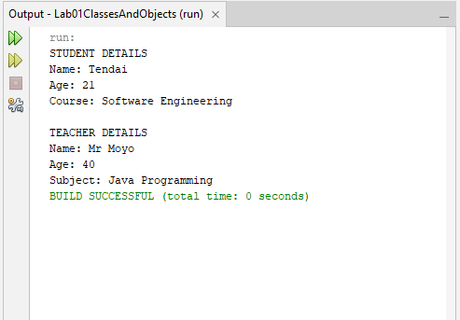
Explanation: Student and Teacher both extend Person. They reuse the parent's name, age, and display() method while adding their own attributes. This is called hierarchical inheritance because two subclasses inherit from one parent class.
Conclusion: The program demonstrates code reuse, reduced duplication, and specialization through inheritance.

Exercise 3: Multilevel Inheritance
Aim: To demonstrate multilevel inheritance and identify the order of constructor execution.
Source Code
Vehicle.java
package lab04inheritance;

// Base class for all vehicles
public class Vehicle {

public Vehicle() {
System.out.println("Vehicle constructor called.");
}
}
Car.java
package lab04inheritance;

// Car inherits from Vehicle
public class Car extends Vehicle {

public Car() {
System.out.println("Car constructor called.");
}
}
ElectricCar.java
package lab04inheritance;

// ElectricCar inherits from Car
public class ElectricCar extends Car {

public ElectricCar() {
System.out.println("ElectricCar constructor called.");
}
}
Main.java

package lab04inheritance;

// Tests multilevel inheritance and constructor order
public class Main {

public static void main(String[] args) {

System.out.println("Creating an ElectricCar:");

ElectricCar electricCar = new ElectricCar();
}
}
Output
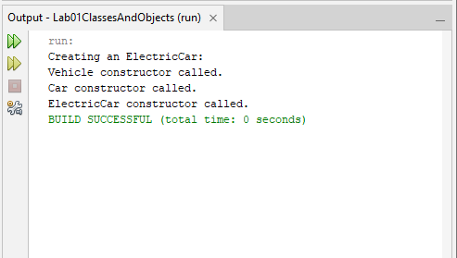
Explanation: Car extends Vehicle, while ElectricCar extends Car. When an ElectricCar object is created, Java executes the Vehicle constructor first, followed by the Car constructor and finally the ElectricCar constructor. This ensures that the inherited parts of the object are initialized before the subclass.
Conclusion: The program demonstrates multilevel inheritance and confirms that constructors execute from the parent class to the child class.

Exercise 4: Constructor Inheritance
Aim: To explain why a subclass fails to compile when its parent class has only a parameterized constructor.
Source Code
Animal.java
package lab04inheritance;

// Parent class with a parameterized constructor
public class Animal {

protected String name;

public Animal(String name) {
this.name = name;
}
}
Dog.java

package lab04inheritance;

// Dog inherits from Animal
public class Dog extends Animal {

public Dog(String name) {
super(name);
System.out.println("Dog constructor called.");
}

public void display() {
System.out.println("Animal name: " + name);
}
}
Main.java

package lab04inheritance;

// Tests the corrected Dog constructor
public class Main {

public static void main(String[] args) {

Dog dog = new Dog("Buddy");

dog.display();
}
}
Output
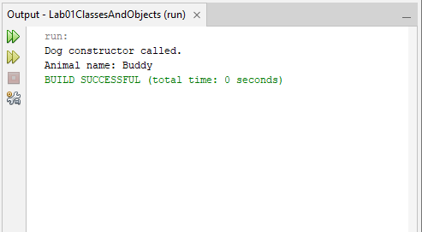
Explanation: When a subclass constructor does not explicitly call a parent constructor, Java attempts to insert super(). This fails if the parent class has no no-argument constructor. In this example, Animal only provides Animal(String name), so Dog must call super(name) and supply the required argument.
Conclusion: The exercise demonstrates that constructors are not inherited and that a subclass must correctly invoke an available parent constructor.

Exercise 5: Composition versus Inheritance
Aim: To refactor a stack implemented through inheritance into a stack that uses composition.
Source Code
MyStack.java

package lab04inheritance;

import java.util.ArrayList;

// Stack uses composition instead of extending ArrayList
public class MyStack<T> {

// The list is private, so callers cannot access it directly
private final ArrayList<T> items = new ArrayList<>();

// Adds an item to the top of the stack
public void push(T item) {
items.add(item);
}

// Removes and returns the top item
public T pop() {
if (items.isEmpty()) {
throw new IllegalStateException("Stack is empty.");
}

return items.remove(items.size() - 1);
}

// Returns the top item without removing it
public T peek() {
if (items.isEmpty()) {
throw new IllegalStateException("Stack is empty.");
}

return items.get(items.size() - 1);
}

// Checks whether the stack is empty
public boolean isEmpty() {
return items.isEmpty();
}

// Returns the number of items in the stack
public int size() {
return items.size();
}
}
Main.java

package lab04inheritance;

// Tests the stack implemented using composition
public class Main {

public static void main(String[] args) {

MyStack<String> stack = new MyStack<>();

// Adds three items
stack.push("Book");
stack.push("Laptop");
stack.push("Phone");

System.out.println("Stack size: " + stack.size());
System.out.println("Top item: " + stack.peek());

// Removes items in LIFO order
System.out.println("Removed: " + stack.pop());
System.out.println("Removed: " + stack.pop());
System.out.println("Removed: " + stack.pop());

System.out.println("Is stack empty: " + stack.isEmpty());
}
}
Output
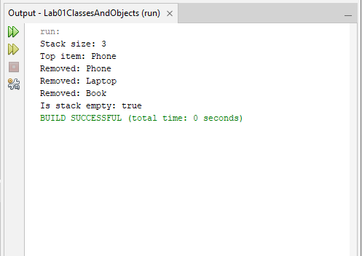
Explanation: A stack implemented as Stack extends ArrayList exposes all public methods inherited from ArrayList, including operations that allow insertion or removal at arbitrary positions. This weakens the stack's LIFO behaviour. The improved MyStack class contains a private ArrayList and provides only push(), pop(), peek(), isEmpty(), and size(). This is composition because the stack contains and uses another object rather than inheriting its entire interface.
Conclusion: Composition provides better control over the stack's behaviour and prevents callers from directly using inappropriate list operations.

